**Computer Vision Assignment – 1**

**Sudheera Sivani Billakurti - S20160010014**

**Subhadeep Dash - S20160010021**

**V. Tejkiran - S20160020155**

**Question-1: Hybrid images**

**1. Initialization of libraries:**

1. **import numpy as np**
2. **from matplotlib import pyplot as plt**
3. **from matplotlib import image as mpimg**

**The above snippet of code is for importing the libraries numpy for vectorization and matplotlib for reading and displaying images.**

**2. Hybrid Image conversion function:**

1. **def hybridImages(image1, image2, alpha, beta):**
2. **def highpass(values, alpha):**
3. **(M, N) = (values.shape[0], values.shape[1])**
4. **for i in range(M):**
5. **for j in range(N):**
6. **if(np.linalg.norm((i, j)) < alpha):**
7. **values[i, j] = 0**
8. **return values**
9. **def lowpass(values, beta):**
10. **(M, N) = (values.shape[0], values.shape[1])**
11. **for i in range(M):**
12. **for j in range(N):**
13. **if(np.linalg.norm((i, j)) > beta):**
14. **values[i, j] = 0**
15. **return values**
16. **image1 = np.array(mpimg.imread(image1))**
17. **image2 = np.array(mpimg.imread(image2))**
18. **if(image1.shape != image2.shape):**
19. **if(image1.shape > image2.shape):**
20. **image1 = image1[:image2.shape[0], :image2.shape[1]]**
21. **else:**
22. **image2 = image2[:image1.shape[0], :image1.shape[1]]**
23. **red1 = image1[:, :, 0]**
24. **green1 = image1[:, :, 1]**
25. **blue1 = image1[:, :, 2]**
26. **red2 = image2[:, :, 0]**
27. **green2 = image2[:, :, 1]**
28. **blue2 = image2[:, :, 2]**
29. **plt.figure();**
30. **plt.imshow(image1)**
31. **plt.show();**
32. **plt.figure();**
33. **plt.imshow(image2);**
34. **plt.show();**
35. **freq_image1_red = np.fft.fft2(red1)**
36. **freq_image1_green = np.fft.fft2(green1)**
37. **freq_image1_blue = np.fft.fft2(blue1)**
38. **freq_image2_red = np.fft.fft2(red2)**
39. **freq_image2_green = np.fft.fft2(green2)**
40. **freq_image2_blue = np.fft.fft2(blue2)**
41. **freq_image1_red = highpass(freq_image1_red, alpha)**
42. **freq_image1_green = highpass(freq_image1_green, alpha)**
43. **freq_image1_blue = highpass(freq_image1_blue, alpha)**
44. **freq_image2_red = lowpass(freq_image2_red, beta)**
45. **freq_image2_green = lowpass(freq_image2_green, beta)**
46. **freq_image2_blue = lowpass(freq_image2_blue, beta)**
47. **final_image_red = freq_image1_red + freq_image2_red**
48. **final_image_green = freq_image1_green + freq_image2_green**
49. **final_image_blue = freq_image1_blue + freq_image2_blue**
50. **final_image_red = np.fft.ifft2(final_image_red)**
51. **final_image_blue = np.fft.ifft2(final_image_blue)**
52. **final_image_green = np.fft.ifft2(final_image_green)**
53. **final_image = np.zeros(image1.shape)**
54. **final_image[:,:,0] = np.absolute(final_image_red)**
55. **final_image[:,:,1] = np.absolute(final_image_green)**
56. **final_image[:,:,2] = np.absolute(final_image_blue)**
57. **return np.absolute(final_image)/np.max(np.absolute(final_image))**

**The above function is used to apply low pass and high pass filters in the frequency domain of the images and further merging them in frequency domain to give a single hybrid image. The lines 2-8 define the high pass filter which allows the frequencies greater than a certain value $α$ to pass and suppresses other frequencies whereas the lines 9-15 define the low pass filter which only allow frequencies less than $β$ to pass.**

**In the lines 16-17, the images are read using imread function and from the lines 18 to 22, both the images are made to the same length and width, if they aren’t of same shape. In the lines 23-28, the channels are separated in three channels for each image and then in the next 6 lines, we view the images. In the lines 35-46, the data in the channels are converted to frequency domain individually and high pass function is applied on the first image whereas low pass function is applied on the second image. In the next three lines, the result frequency intensities are merged into one and are converted to spatial domain in the further 3 lines. Then, we define the final image and assign the resultant channels to it and return the absolute normalized value of the resultant image as the final output.**

**INPUTS:**

1. **plt.imshow(hybridImages("marilyn.bmp", "einstein.bmp", 25, 1000))**
2. **plt.show()**
3. **plt.imshow(hybridImages("Afghan_girl_before.jpg","Afghan_girl_after.jpg", 25, 750))**
4. **plt.show()**

1. **plt.imshow(hybridImages("bicycle.bmp", "motorcycle.bmp", 25, 750))**
2. **plt.show()**
3. **plt.imshow(hybridImages("fish.bmp", "submarine.bmp", 25, 750))**
4. **plt.show()**
5. **plt.imshow(hybridImages("bird.bmp", "plane.bmp", 25, 750))**
6. **plt.show()**
7. **plt.imshow(hybridImages("cat.bmp", "dog.bmp", 5, 750))**
8. **plt.show()**
9. **plt.imshow(hybridImages("makeup_before.jpg", "makeup_after.jpg", 5, 750))**
10. **plt.show()**

**RESULTS:**

**The output of the resultant function on various images can be seen below. In each of the sets, the first two images are the inputs to the function and the final image is the hybrid image obtained.**

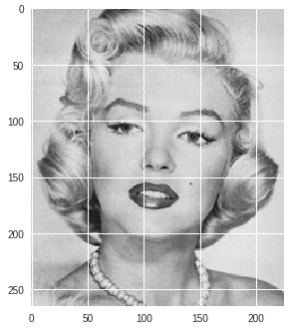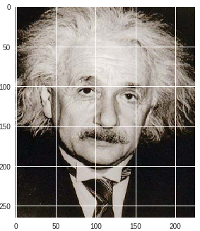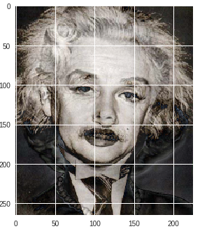

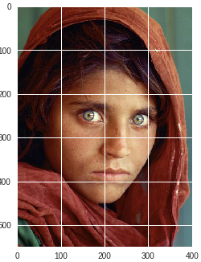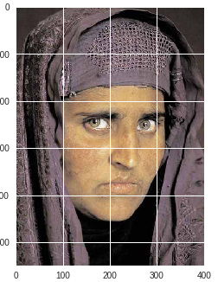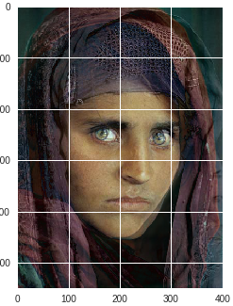

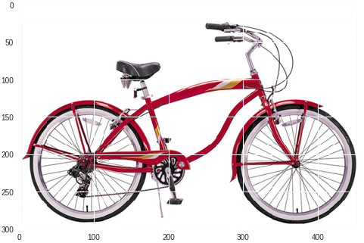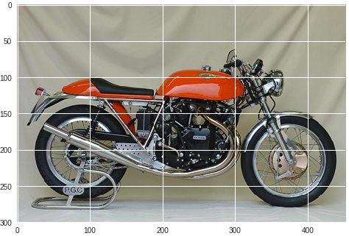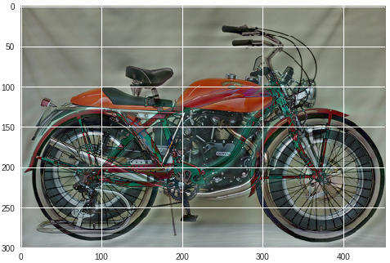

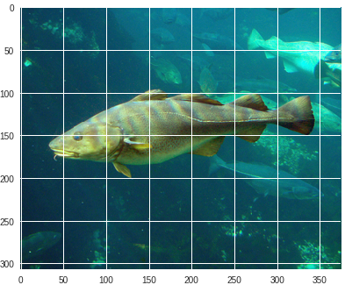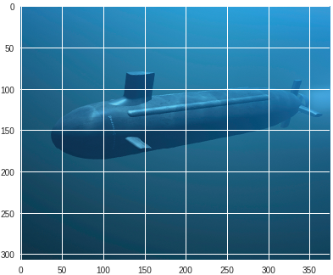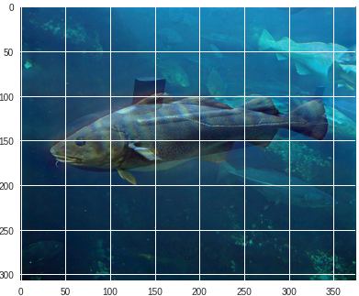

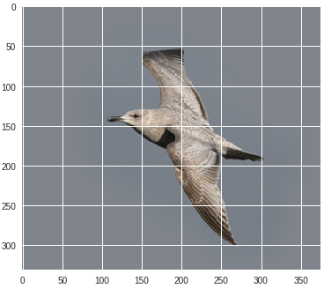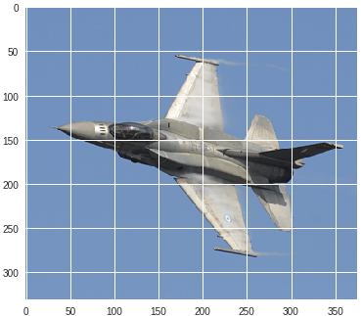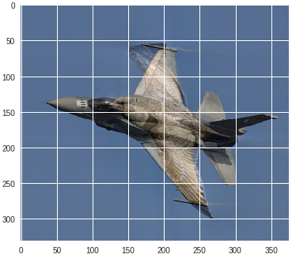

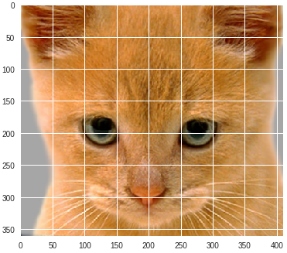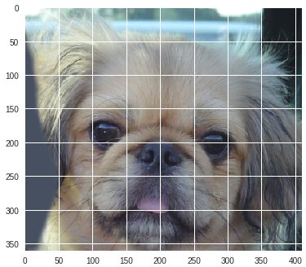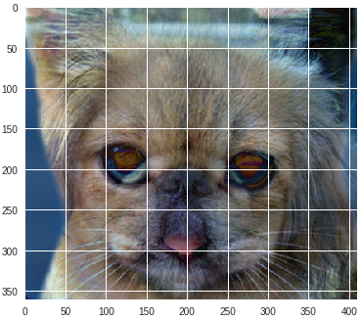  
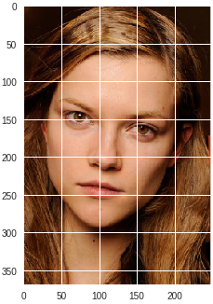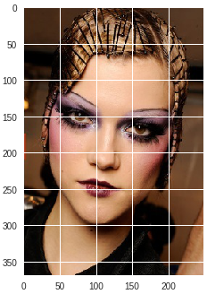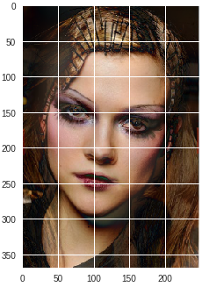

**Question-2: Corner Detection**

**1. Initialization of libraries:**

1. **import numpy as np**
2. **import matplotlib.pyplot as plt**
3. **from matplotlib import image as mpimg**

**The above snippet of code is for importing the libraries numpy for vectorization and matplotlib for reading and displaying images.**

**2. Shi-Tomasi Corner detection algorithm:**

1. **def shi_tomasi(org_image, threshold, window_size):**
2. **org_image = np.array(mpimg.imread(org_image))**
3. **plt.figure()**
4. **plt.imshow(org_image)**
5. **plt.show()**
6. **if(len(org_image.shape) == 3):**
7. **image = np.dot(org_image[...,:3], [0.299, 0.587, 0.114])**
8. **else:**
9. **image = org_image**
10. **left_shifted_image = np.concatenate((image[:, 1:], image[:,-1:]), axis=1)**
11. **up_shifted_image = np.concatenate((image[1:, :], image[-1:,:]), axis=0)**
12. **x_change = left_shifted_image-image**
13. **y_change = up_shifted_image-image**
14. **new_image = np.zeros(image.shape)**
15. **m = image.shape[0]**
16. **n = image.shape[1]**
17. **for i in range(window_size//2, m-window_size//2):**
18. **for j in range(window_size//2, n-window_size//2):**
19. **A = np.square(x_change[i-window_size//2:i+window_size//2, j-window_size//2:j+window_size//2]).sum()**
20. **B = np.multiply((x_change[i-window_size//2:i+window_size//2, j-window_size//2:j+window_size//2]),(y_change[i-window_size//2:i+window_size//2, j-window_size//2:j+window_size//2])).sum()**
21. **C = np.square(y_change[i-window_size//2:i+window_size//2, j-window_size//2:j+window_size//2]).sum()**
22. **H = np.array([[A, B], [B, C]])**
23. **min_lambda = np.min(np.linalg.eigvals(H))**
24. **if(min_lambda > threshold):**
25. **if(len(org_image.shape) == 3):**
26. **org_image[i][j] = [255, 0, 0]**
27. **else:**
28. **org_image[i][j] = 255**
29. **new_image[i][j] = 255**
30. **return org_image, new_image**

**The gradients in each direction i.e. horizontally and vertically is calculated in lines 12-13. Then within a given window the second moment matrix is calculated as follows:**

$$Second moment Matrix= \left[\begin{matrix}A & B \\ B & C\end{matrix}\right]=\left[\begin{matrix}\sum{I_{x}^{2}} & \sum{I_{x}I_{y}} \\ \sum{I_{x}I_{y}} & \sum{I_{y}^{2}}\end{matrix}\right]$$

**Then the eigen values for the matrix are calculated and it is checked if the minimum of them is above a threshold value. If $λ_{min}>threshold$, then it is marked a corner.**

**2. Harris Corner detection algorithm:**

1. **def harris_corners(org_image, threshold, window_size, k):**
2. **org_image = np.array(mpimg.imread(org_image))**
3. **plt.figure()**
4. **plt.imshow(org_image)**
5. **plt.show()**
6. **if(len(org_image.shape) == 3):**
7. **image = np.dot(org_image[...,:3], [0.299, 0.587, 0.114])**
8. **else:**
9. **image = org_image**
10. **left_shifted_image = np.concatenate((image[:, 1:], image[:,-1:]), axis=1)**
11. **up_shifted_image = np.concatenate((image[1:, :], image[-1:,:]), axis=0)**
12. **x_change = left_shifted_image-image**
13. **y_change = up_shifted_image-image**
14. **new_image = np.zeros(image.shape)**
15. **m = image.shape[0]**
16. **n = image.shape[1]**
17. **for i in range(window_size//2, m-window_size//2):**
18. **for j in range(window_size//2, n-window_size//2):**
19. **A = np.square(x_change[i-window_size//2:i+window_size//2, j-window_size//2:j+window_size//2]).sum()**
20. **B = np.multiply((x_change[i-window_size//2:i+window_size//2, j-window_size//2:j+window_size//2]),(y_change[i-window_size//2:i+window_size//2, j-window_size//2:j+window_size//2])).sum()**
21. **C = np.square(y_change[i-window_size//2:i+window_size//2, j-window_size//2:j+window_size//2]).sum()**
22. **H = np.array([[A, B], [B, C]])**
23. **f = np.linalg.det(H) - k*np.square(np.trace(H))**
24. **if(f > threshold):**
25. **if(len(org_image.shape) == 3):**
26. **org_image[i][j] = [255, 0, 0]**
27. **else:**
28. **org_image[i][j] = 255**
29. **new_image[i][j] = 255**
30. **return org_image, new_image**

**In the Harris corner detection function, he second moment matrix is computed similar as in previous case. The only difference is the condition based on which it’s decided if it’s a corner or not. A point is considered a corner if the following condition satisfies:**

$$det\left(\left[\begin{matrix}\sum{I_{x}^{2}} & \sum{I_{x}I_{y}} \\ \sum{I_{x}I_{y}} & \sum{I_{y}^{2}}\end{matrix}\right]\right)-k*\left(trace\left(\left[\begin{matrix}\sum{I_{x}^{2}} & \sum{I_{x}I_{y}} \\ \sum{I_{x}I_{y}} & \sum{I_{y}^{2}}\end{matrix}\right]\right)\right)>threshold$$

**Where k is a constant.**

**INPUTS:**

**1) Shi-Tomasi Corner Detection Algorithm:**

1. **corners_placed, corners = shi_tomasi("chess.jpg", 1000, 7)**
2. **plt.figure()**
3. **plt.imshow(corners_placed)**
4. **plt.show()**
5. **plt.figure()**
6. **plt.imshow(corners, cmap="gray")**
7. **plt.show()**

**We have tested the corner detection image on an additional chess board image apart from the data provided.**

1. **corners_placed, corners = shi_tomasi("Image1.jpg", 100, 3)**
2. **plt.figure()**
3. **plt.imshow(corners_placed)**
4. **plt.show()**
5. **plt.figure()**
6. **plt.imshow(corners, cmap="gray")**
7. **plt.show()**
8. **corners_placed, corners = shi_tomasi("Image2.jpg", 100, 3)**
9. **plt.figure()**
10. **plt.imshow(corners_placed)**
11. **plt.show()**
12. **plt.figure()**
13. **plt.imshow(corners, cmap="gray")**
14. **plt.show()**
15. **corners_placed, corners = shi_tomasi("Image3.jpg", 100, 3)**
16. **plt.figure()**
17. **plt.imshow(corners_placed)**
18. **plt.show()**
19. **plt.figure()**
20. **plt.imshow(corners, cmap="gray")**
21. **plt.show()**

**2) Harris Corner Detection Algorithm:**

1. **corners_placed, corners = harris_corners("chess.jpg", 2000, 9, 0.24)**
2. **plt.figure()**
3. **plt.imshow(corners_placed)**
4. **plt.show()**
5. **plt.figure()**
6. **plt.imshow(corners, cmap="gray")**
7. **plt.show()**
8. **corners_placed, corners = harris_corners("Image1.jpg", 20000, 3, 0.10)**
9. **plt.figure()**
10. **plt.imshow(corners_placed)**
11. **plt.show()**
12. **plt.figure()**
13. **plt.imshow(corners, cmap="gray")**
14. **plt.show()**
15. **corners_placed, corners = harris_corners("Image2.jpg", 10000, 3, 0.1)**
16. **plt.figure()**
17. **plt.imshow(corners_placed)**
18. **plt.show()**
19. **plt.figure()**
20. **plt.imshow(corners, cmap="gray")**
21. **plt.show()**
22. **corners_placed, corners = harris_corners("Image3.jpg", 20000, 3, 0.10)**
23. **plt.figure()**
24. **plt.imshow(corners_placed)**
25. **plt.show()**
26. **plt.figure()**
27. **plt.imshow(corners, cmap="gray")**
28. **plt.show()**

**RESULTS:**

**1) Shi-Tomasi Corner Detection Algorithm:**

**In each row, the first image is the original image. The second image contains the picture as well as the points. The third image contains the corners.**

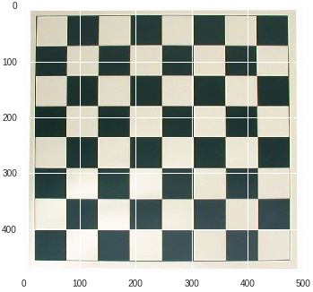 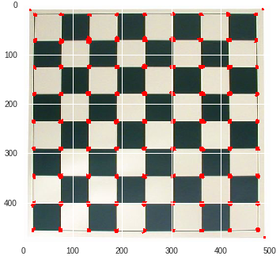

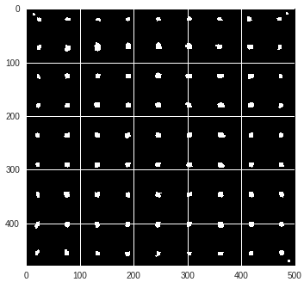

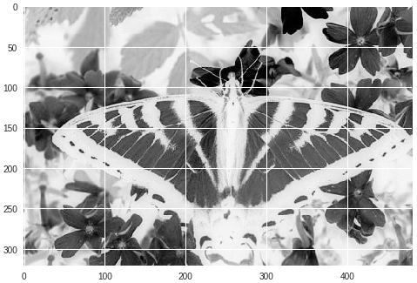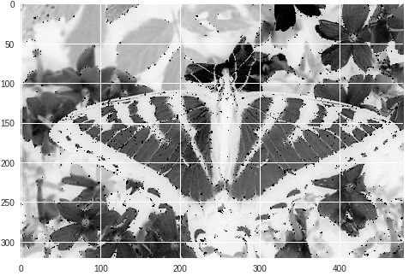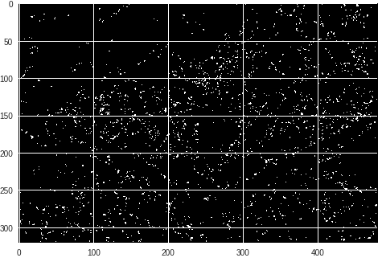

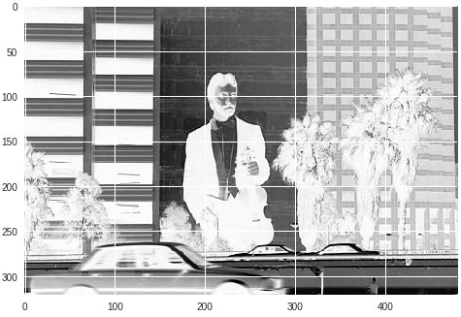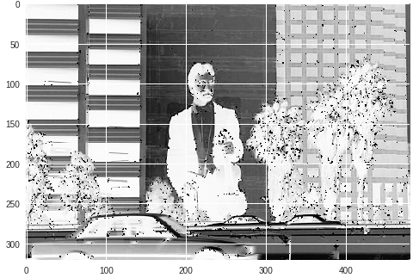

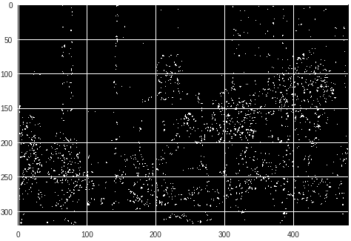

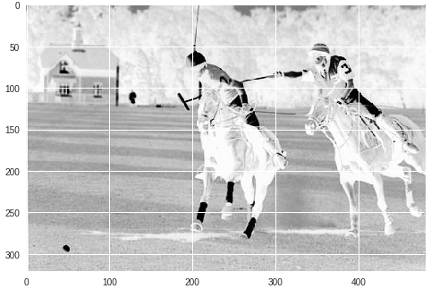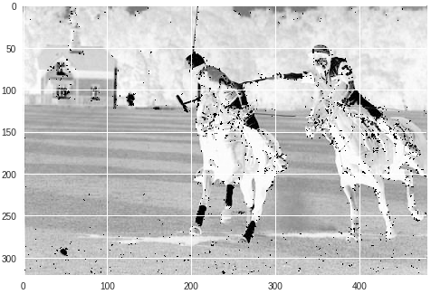

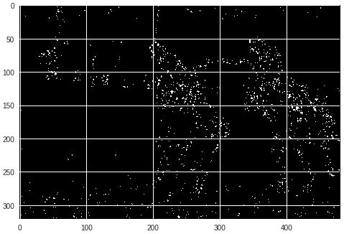

**2) Harris Corner Detection Algorithm:**

**In each row, the first image is the original image. The second image contains the picture as well as the points. The third image contains the corners.**

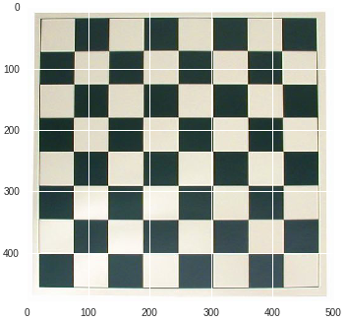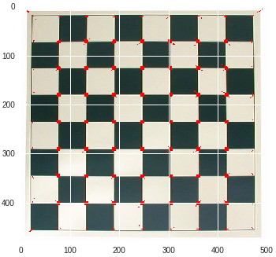

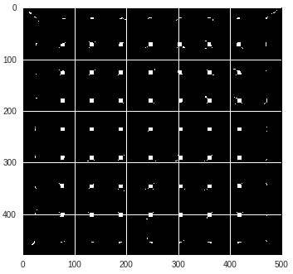

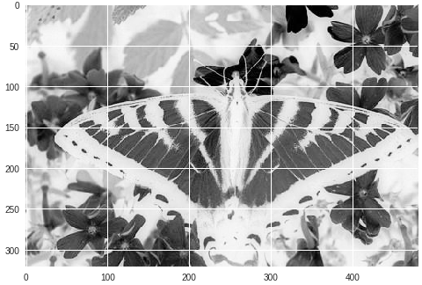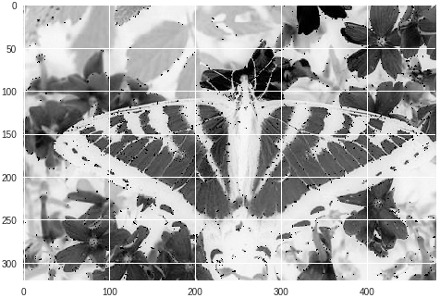

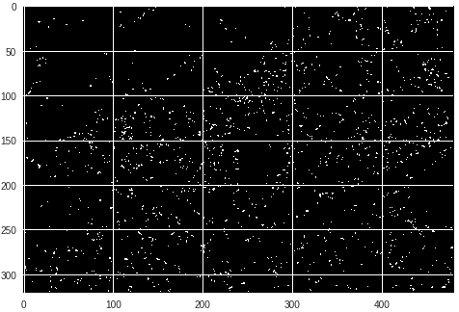

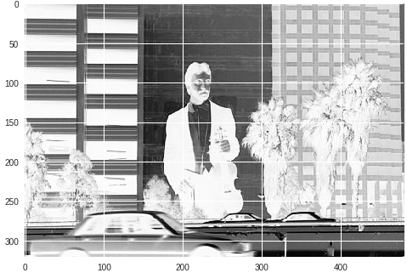 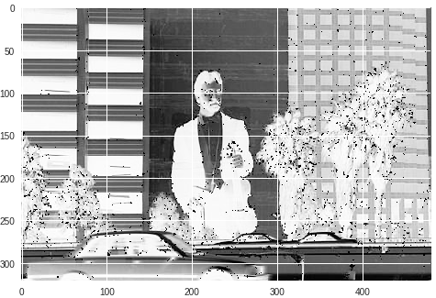

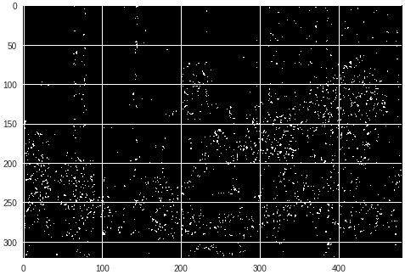

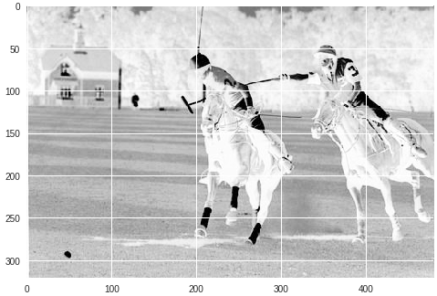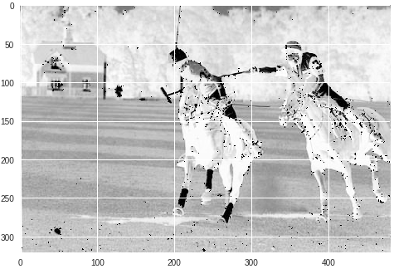

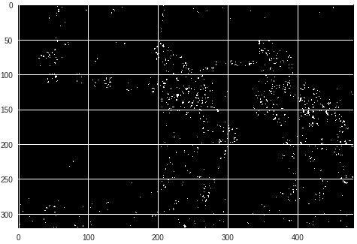

**Question-3: Scale space blob detection**

**1. Initialization of libraries:**

1. **import numpy as np**
2. **import time**
3. **import matplotlib.pyplot as plt**
4. **import matplotlib.image as mpimg**

**2. Various functions:**

1. **def Laplacian_of_Gaussian(n, sigma):**
2. **laplacian = np.array([range(-n//2+1, n//2+1, 1) for _ in range(n)])**
3. **common_factor = (np.square(laplacian)+np.square(laplacian.T))**
4. **laplacian = (common_factor-2*np.square(sigma))*np.exp(-common_factor/(2*np.square(sigma)))**
5. **return Laplacian**
6. **def Gaussian_filter(n, sigma):**
7. **gaus_filter = np.array([range(-n//2+1, n//2+1, 1) for _ in range(n)])**
8. **gaus_filter = np.square(gaus_filter) + np.square(gaus_filter.T)**
9. **gaus_filter = (1/(2*np.pi*np.square(sigma)))*np.exp(-gaus_filter/(2*np.square(sigma)))**
10. **#gaus_filter = np.repeat(gaus_filter, 3).reshape(n, n, 3)**
11. **return(gaus_filter)**
13. **def dog(k,n,sigma):**
14. **a=Gaussian_filter(n,sigma)**
15. **b=Gaussian_filter(n,k*sigma)**
16. **return b-a**
18. **def padding(image, n):**
19. **padded_image = np.concatenate((np.array([image[0] for _ in range(n//2)]), image, np.array([image[-1] for _ in range(n//2)])), axis=0)**
20. **padded_image = np.concatenate((np.repeat(padded_image[:, 0:1],n//2, axis=1), padded_image, np.repeat(padded_image[:, -1:],n//2, axis=1)), axis=1)**
21. **return padded_image**
22. **def apply_filter(img, lapl):**
23. **M, N = img.shape**
24. **K = lapl.shape[0]**
25. **final_image = np.zeros(img.shape)**
26. **for i in range(M-K):**
27. **for j in range(N-K):**
28. **final_image[i+K//2, j+K//2] = np.multiply(img[i:i+K, j:j+K], lapl).sum()**
29. **return np.square(final_image)**
30. **def max_filter(img, K, sigma):**
31. **M, N = img.shape**
32. **final_image = np.zeros(img.shape)**
33. **plt.figure()**
34. **fig, ax = plt.subplots()**
35. **for i in range(M-K):**
36. **for j in range(N-K):**
37. **if(img[i+K//2, j+K//2] == np.max(img[i:i+K, j:j+K])):**
38. **final_image[i+K//2, j+K//2] = np.sqrt(2)*sigma**
39. **ax.add_artist(plt.Circle((j+K//2, i+K//2), np.sqrt(2)*sigma, color='r', fill = False, linewidth=3))**
40. **plt.imshow(final_image, cmap="gray")**
41. **plt.show()**
42. **return final_image**

**Implementation of various functions such as Laplacian of Gaussian (in lines 1-5), Gaussian (in lines 7-12) and Difference of Gaussian (in lines 14-17), Padding (in lines 19-22), Convolution (in lines 24-31) and Non-max Suppression (in lines 33-45).**

1. **start = time.time()**
2. **n = 10**
3. **path = "butterfly.jpg"**
4. **org_sigma=3.5**
5. **factor = 1.21**
6. **filter_type = 1**
7. **org_image = mpimg.imread(path)**
8. **if(len(org_image.shape) == 3):**
9. **image = np.dot(org_image[...,:3], [0.299, 0.587, 0.114])**
10. **else:**
11. **image = org_image**
12. **layers = np.zeros((n, image.shape[0], image.shape[1]))**
13. **for i in range(n):**
14. **sigma = org_sigma*np.power(factor, i)**
15. **window_size = int(np.ceil(6*sigma))**
16. **if(window_size%2 == 0):**
17. **window_size += 1**
18. **if(filter_type == 1):**
19. **LoG = Laplacian_of_Gaussian(window_size, sigma)**
20. **else:**
21. **LoG=dog(np.power(factor, i+1),window_size,org_sigma)**
22. **plt.figure()**
23. **layers[i] = apply_filter(padding(image, window_size), LoG)[window_size//2:-window_size//2+1, window_size//2:-window_size//2+1]**
24. **plt.imshow(layers[i], cmap = "gray")**
25. **centres = np.zeros(layers.shape)**
26. **for i in range(n):**
27. **sigma = org_sigma*np.power(factor, i)**
28. **window_size = int(np.ceil(6*sigma))**
29. **if(window_size%2 == 0):**
30. **window_size += 1**
31. **centres[i] = max_filter(layers[i], window_size, sigma)**
32. **plt.figure()**
33. **fig, ax = plt.subplots()**
34. **for i in range(centres.shape[0]):**
35. **sigma = org_sigma*np.power(factor, i)**
36. **for j in range(centres.shape[1]):**
37. **for k in range(centres.shape[2]):**
38. **if(centres[i][j][k]!=0 and centres[i, j, k] == np.max(centres[:, int(j-np.sqrt(2)*sigma):int(j+np.sqrt(2)*sigma), k-int(np.sqrt(2)*sigma):k+int(np.sqrt(2)*sigma)])):**
39. **ax.add_artist(plt.Circle((k, j), np.sqrt(2)*sigma, color='r', fill = False, linewidth=1))**
40. **plt.imshow(org_image)**
41. **plt.show()**
42. **end = time.time()**
43. **elapsed = end - start**
44. **print(elapsed)**

**In this snippet, the variables n, org_sigma, factor, path are used to represent the number of iterations, the initial standard deviation, the factor by which standard deviation is scaled every iteration, the path of the image file respectively and the filter_type 1 corresponds to usage of Laplacian of Gaussian filter whereas filter_type 2 refers to the usage of Difference of Gaussian filter.**

**The line 7 reads the image and immediate after we convert the 3D RGB image to grayscale image. From the lines 12-24, the filter is applied with the scaled variance and then after applying non-max suppression the resultant information is stored in the layers list. Then the lines (25-32) perform the non-max suppression on the image giving centers to the circles of radius $\sqrt{2}σ$. These centers are stored in center list on which again Non-max Suppression is applied over the stack of layers and only then the circles are plotted with their respective radii.**

**INPUTS:**

**The following parameters are send for detecting blobs:**

1. **n = 10**
2. **path = "butterfly.jpg"**
3. **org_sigma=3.5**
4. **factor = 1.21**
5. **filter_type = 1**
6. **n = 10**
7. **path = "butterfly.jpg"**
8. **org_sigma=3.5**
9. **factor = 1.21**
10. **filter_type = 2**
11. **n = 10**
12. **path = "einstein.jpg"**
13. **org_sigma=3.5**
14. **factor = 1.21**
15. **filter_type = 1**
16. **n = 10**
17. **path = "einstein.jpg"**
18. **org_sigma=3.5**
19. **factor = 1.21**
20. **filter_type = 2**

1. **n = 10**
2. **path = "fishes.jpg"**
3. **org_sigma=3.5**
4. **factor = 1.21**
5. **filter_type = 1**
6. **n = 10**
7. **path = "fishes.jpg"**
8. **org_sigma=3.5**
9. **factor = 1.21**
10. **filter_type = 2**
11. **n = 10**
12. **path = "sunflowers.jpg"**
13. **org_sigma=3.5**
14. **factor = 1.21**
15. **filter_type = 1**
16. **n = 10**
17. **path = "sunflowers.jpg"**
18. **org_sigma=3.5**
19. **factor = 1.21**
20. **filter_type = 2**
21. **n = 10**
22. **path = "flowers.jpeg"**
23. **org_sigma=3.5**
24. **factor = 1.21**
25. **filter_type = 1**
26. **n = 10**
27. **path = "flowers.jpeg"**
28. **org_sigma=3.5**
29. **factor = 1.21**
30. **filter_type = 2**
31. **n = 10**
32. **path = "colors.jpeg"**
33. **org_sigma=3.5**
34. **factor = 1.21**
35. **filter_type = 1**
36. **n = 10**
37. **path = "colors.jpeg"**
38. **org_sigma=3.5**
39. **factor = 1.21**
40. **filter_type = 2**
41. **n = 10**
42. **path = "rods.jpeg"**
43. **org_sigma=3.5**
44. **factor = 1.21**
45. **filter_type = 1**
46. **n = 10**
47. **path = "rods.jpeg"**
48. **org_sigma=3.5**
49. **factor = 1.21**
50. **filter_type = 2**
51. **n = 10**
52. **path = "bubbles.jpeg"**
53. **org_sigma=3.5**
54. **factor = 1.21**
55. **filter_type = 1**
56. **n = 10**
57. **path = "bubbles.jpeg"**
58. **org_sigma=3.5**
59. **factor = 1.21**
60. **filter_type = 2**

**RESULTS:**

**The outputs of Laplacian of Gaussian are on left where as the ones of Difference of Gaussian are on right.**

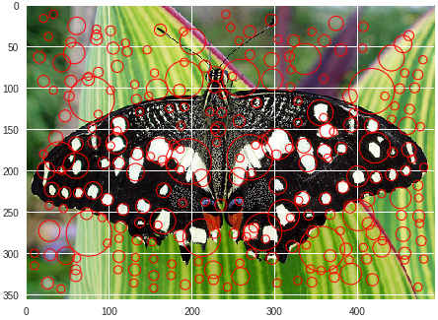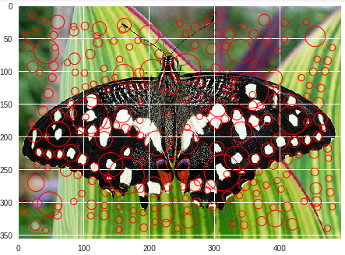

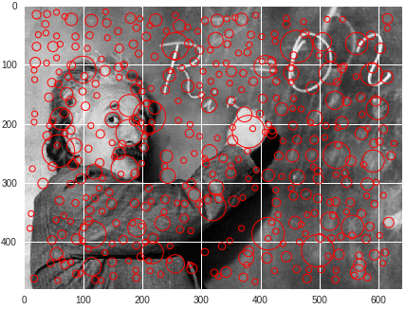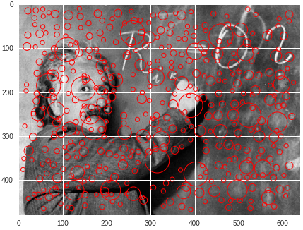

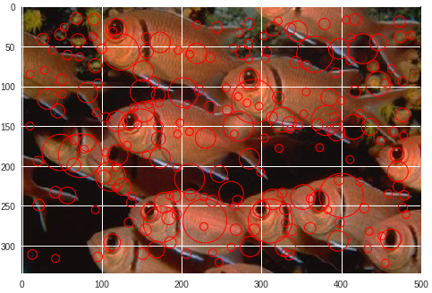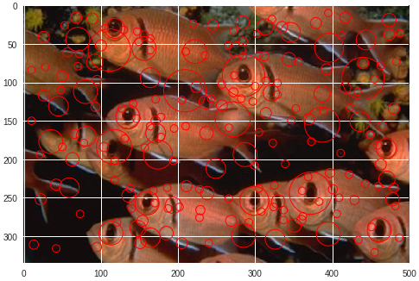

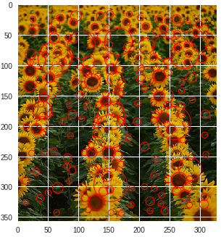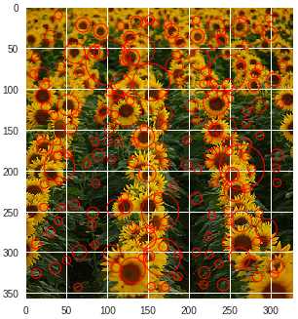

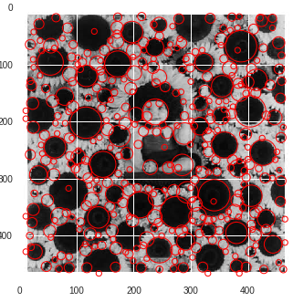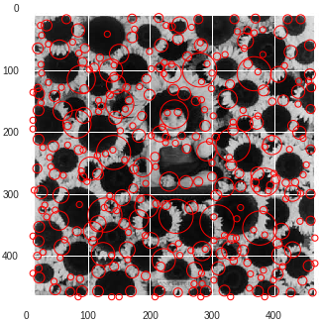

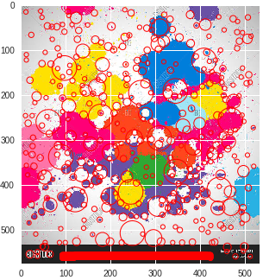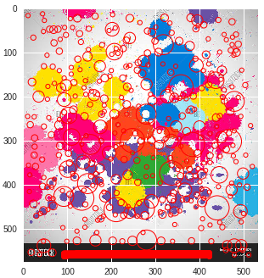

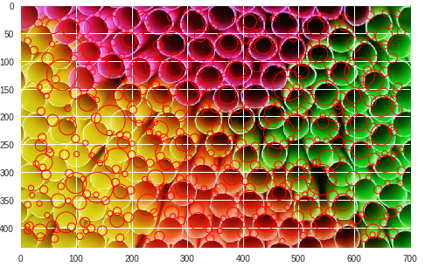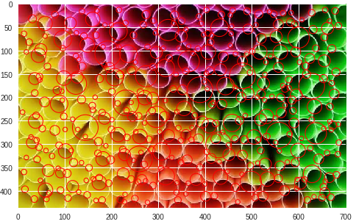

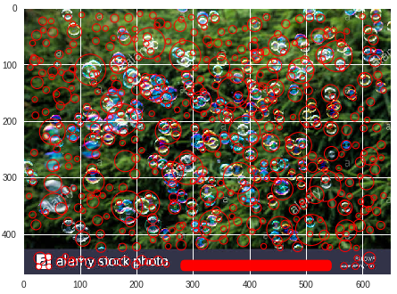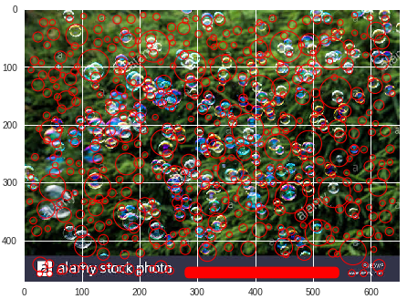

**Comparison of both algorithms based on their runtimes:**

|  |  |  |
| --- | --- | --- |
| **Images** | **Running time of Laplacian of Gaussian (in secs)** | **Running time of Difference of Gaussian (in secs)** |
| **butterfly.jpg** | **34.674816608428955** | **34.38932180404663** |
| **einstein.jpg** | **57.405301094055176** | **57.869709968566895** |
| **fishes.jpg** | **33.20057916641235** | **33.29722452163696** |
| **sunflowers.jpg** | **24.47645902633667** | **24.39238691329956** |
| **flowers.jpeg** | **43.549209117889404** | **43.62589621543884** |
| **colors.jpeg** | **63.052472829818726** | **63.8885293006897** |
| **rods.jpeg** | **58.875545263290405** | **58.92578172683716** |
| **bubbles.jpeg** | **63.670729637145996** | **64.42570161819458** |

**We observe that the runtimes of both the algorithms are quite similar but performance wise, we can see that the Laplacian of Gaussian is better than Difference of Gaussian in detecting blobs.**

**Thanks for Reading**